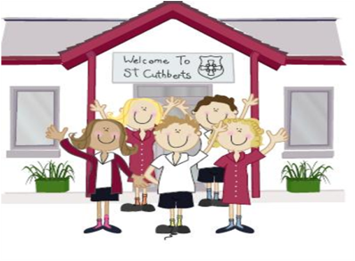333333333333 4th March 2022

FRIDAY NEWSLETTER

3rd

Reception 90%

Year 1 93%

Year 2 96%

Year3 95%

Year 4 94%

Year 5 92%

Year 6 94%

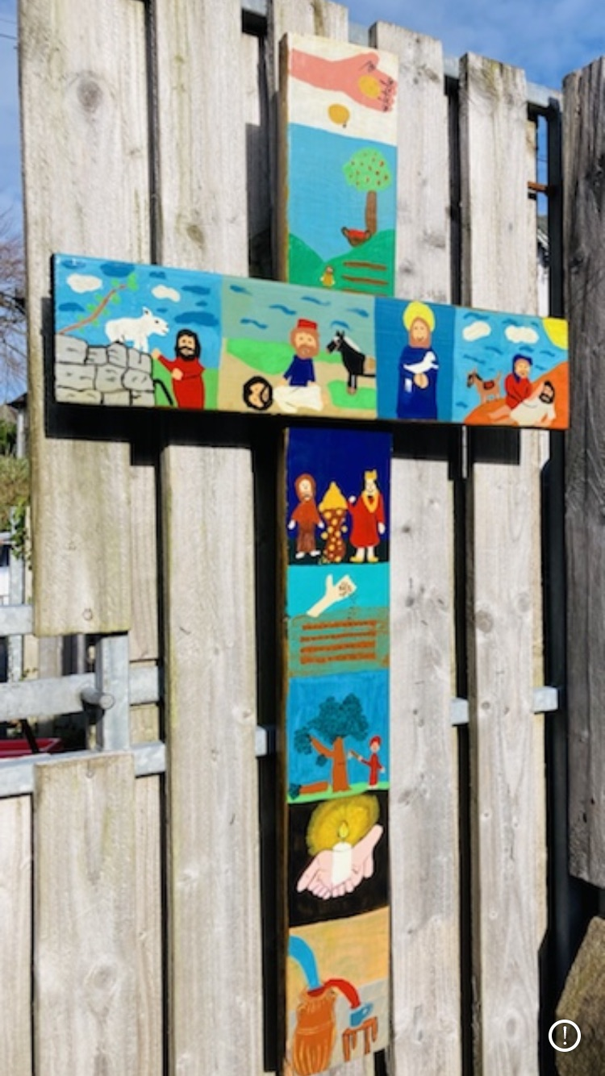

**Head Teacher’s Comments**

Dear Parents and Carers,

We have had another super busy week in school. On Wednesday we joined Father Bernard for Ash Wednesday Mass, as usual our children acted with reverence and respect throughout the service, it was noted by parishioners how well-behaved our children were. They are always a credit to us.

As we enter the season of Lent, the children have been reflecting and writing some very thoughtful Lenten promises. In RE, Year 5 & 6 planted bulbs to symbolise our faith. The children will nurture their bulbs over the next few weeks, as we continue to nurture our faith.

Thank you for your support for our section 48 inspection on Tuesday, the day was extremely positive, we will get a full report in due course. We can't wait to share it with you.

Yesterday Yr. 5&6 girls represented our school at a local Primary school football tournament in Kendal. Well done, we are very proud of you.

On Thursday we celebrated world book day, we had a fantastic day dressed up as our favourite characters. The children designed new book covers, joined in with an interactive book quiz, as well as making super book marks. What a fantastic day!

Today the children have all enjoyed forest schools with Ro. Signs of spring & new life are starting to appear...

Cuthbert's baby and toddler group is thriving, if you know any local families with any preschool children who would like to join us; we meet on Thursday mornings (term time) 9.30 to 11.15am in the Maryholme centre. Everyone is welcome.

Please contact school if you are able to spare any time to hear readers in school. We would be very grateful. We are also looking for new Governors. Whether you're a Parishioner, parent, grandparent or friend - please contact us if you think you would like to join.

We hope you enjoy the weekend, stay safe, **Below is our cross decorated with Luke's parables**

Mrs Tansey  Mrs Bone

Executive Head Head of School.

**World book day**





Mrs Bone and Mrs Tansey

Stay safe,

Mrs Bone and Mrs Tansey

Mrs Bone and Mrs Tansey

Head of School & Executive Head



**DIARY – February 2021**

**Yr 6 are still invited to school at 8.30am for extra maths.**

**Monday 7th March PFA Meeting 3.15 at School**

**Wednesday 9th March KS2 Cross Country in School time**

**Thursday 10th March MOVIE NIGHT 3.15-5pm *£3 per child*.**

**Friday 17th December – School closed for Christmas.**

**Hope you all have a very merry Christmas!!!!**

**Wrap-around Care** - all payments are due in advance when booking please

Breakfast Club is open from 8.15am until 8.45am £2 per child, per session

After-school Club* runs from 3.15pm until 5.15 pm at £4 per child, per session.

*Please book a week in advance to allow staff planning. If less notice is given we cannot guarantee availability.

**ATTENDANCE TEDDY AWARD**



Please stay safe well done all children for all your amazing work….