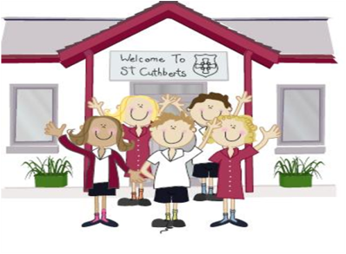333333333333 22nd April 2022

FRIDAY NEWSLETTER

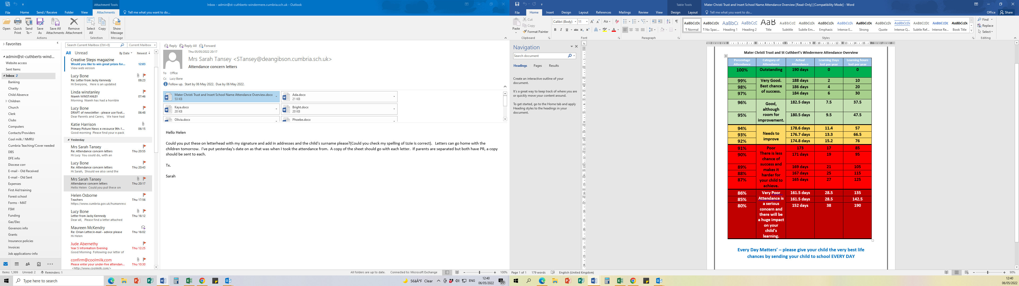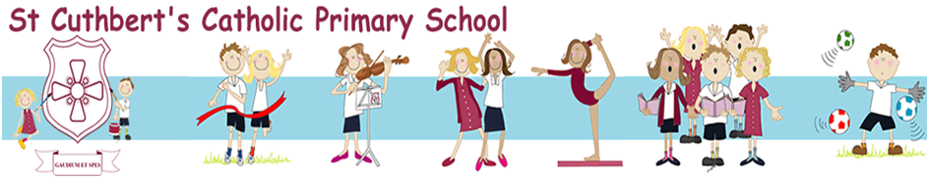3rd

**Football Tournament – Lakes School**

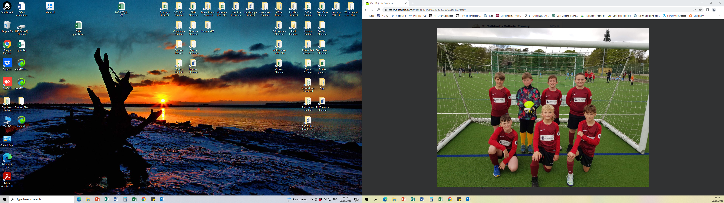

**DIARY – December 2021**

A reminder that we will have to cancel after school club on Tuesday 24th May due to staff training.

* Monday 9th - First Holy Communion after school (instead of Thursday 12th May)
* Thursday 12th - No SATs club.
* Friday - 13th - KS2 swimming

**Hope you all have a lovely weekend!!**

**Wrap-around Care** - all payments are due in advance when booking please

Breakfast Club is open from 8.15am until 8.45am £2 per child, per session

After-school Club* runs from 3.15pm until 5.15 pm at £4 per child, per session.

*Please book a week in advance to allow staff planning. If less notice is given we cannot guarantee availability.

Reception 86%

Year 1 100%

Year 2 100%

Year 3 100%

Year 4 100%

Year 5 89%

Year 6 100%

**Head Teacher’s Comments**

Dear Parents and Carers,

We have had such a lovely week in school.

Our Year 5 / 6 boys football team represented St. Cuthbert's in a football tournament at The Lakes School on Wednesday.  We are very proud that they won every match and were winners of their group. Well done boys. What a great achievement!

The Year 6 have been busy preparing for their SATs. Due to COVID and the disturbance in education over the last 2 years, these are the first SATs since 2019.

We wish them the best of luck next week. This week was the last SATs club.

Science club was a great success on Wednesday. The children have been busy making their volcanoes ready for the experiment next week. The children also made balloon rockets.

First Holy communion is just a few weeks away on Sunday 22nd May at 11.15. Many thanks to Mrs Murray for preparing the 14 children on their Sacramental Journey.

We hope you all enjoy the weekend and stay safe,

Mrs Bone and Mrs Tansey

Stay safe,

Mrs Bone and Mrs Tansey

Mrs Bone and Mrs Tansey

Head of School & Executive Head



WOW! Amazing, year 1 & 4. that’s fantastic!!

Keep

**ATTENDANCE TEDDY AWARD**

