33333333333 22nd April 2022

FRIDAY NEWSLETTER

3rd

Reception 66%

Year 1 100%

Year 2 100%

Year 3 100%

Year 4 100%

Year 5 92%

Year 6 92%

**DIARY - KEY DATES:**

* First Holy communion - Sunday 22nd May
* KS2 BIG SING - 27th May (during school time)
* PFA Jubilee party - 27th May starting at 2.45pm – parents welcome from 3.15pm

**Hope you all have a lovely weekend!!**

**Wrap-around Care** - all payments are due in advance when booking please

Breakfast Club is open from 8.15am until 8.45am £2 per child, per session

After-school Club* runs from 3.15pm until 5.15 pm at £4 per child, per session.

*Please book a week in advance to allow staff planning. If less notice is given we cannot guarantee availability.

**Our children completed the Sacrament of Reconciliation on Wednesday**

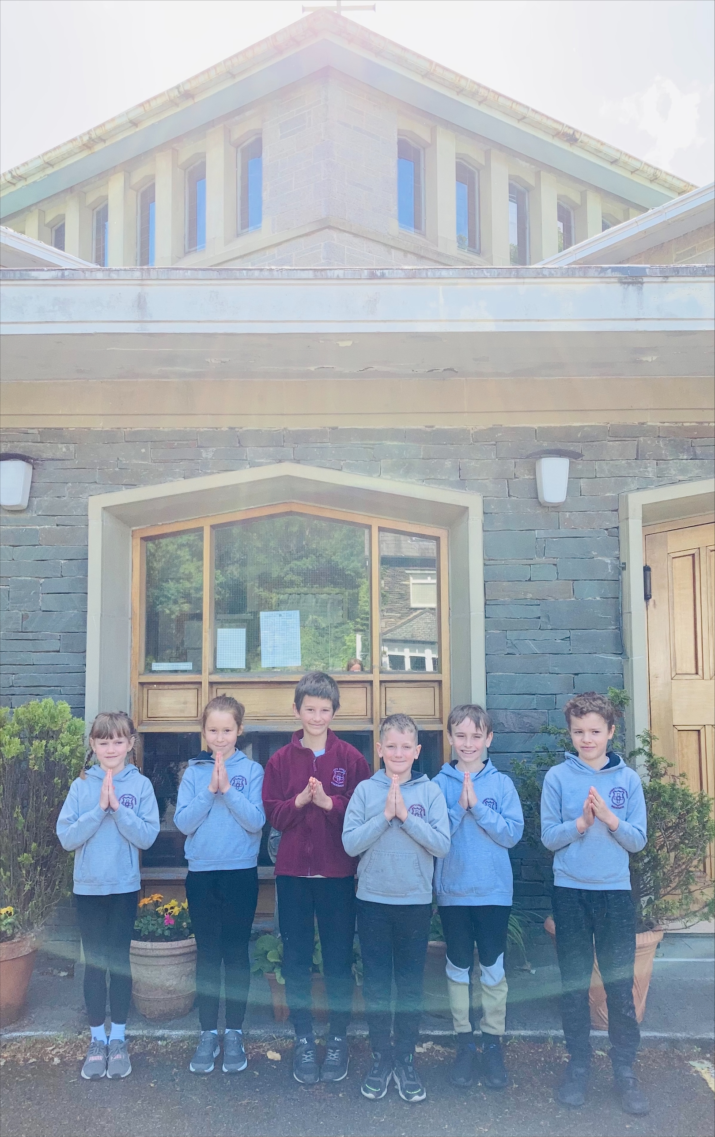

**Head Teacher’s Comments**

Dear Parents and Carers,

What a great week in school.

Year 5 and 6 have enjoyed their residential. We made our own camp in the woods at St Catherines woods. The children had a super time.

Year 2's experienced curriculum swimming today. We think they enjoyed the lovely outside pool. This lesson will help prepare them for September when they are in KS2. We hope they had a lovely time.

We are looking forward to joining our lovely group of children on Sunday as they receive the sacrament of First Holy Communion. Many thanks to Mrs Murray for preparing the children.

We have a busy week next week. On Thursday, we have our open morning. Please spread the word- we have spaces in all year groups. TIMES.

KS2 also have BIG SING on Friday, at Kendal Town Hall. We have been rehearsing and the children sound amazing, This is during the school day.

At 3pm on Friday, the PFA are hosting a Jubilee tea party. Everyone is welcome. Details can be found on the separate poster or our Facebook page.

I hope you enjoy the weekend.

Take care,

Mrs Bone and Mrs Tansey

Stay safe,

Mrs Bone and Mrs Tansey

Mrs Bone and Mrs Tansey

Head of School & Executive Head



WOW! Amazing, year 1 & 4. that’s fantastic!!

Keep

**ATTENDANCE TEDDY AWARD**

