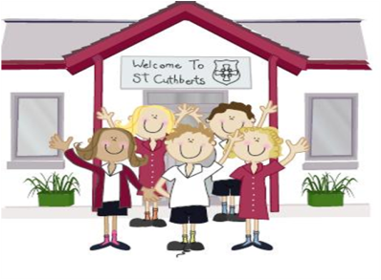333333333333 18th March 2022

FRIDAY NEWSLETTER

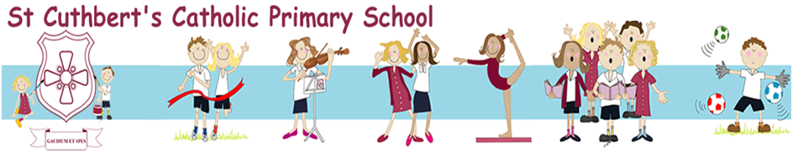3rd

**Bikeability**

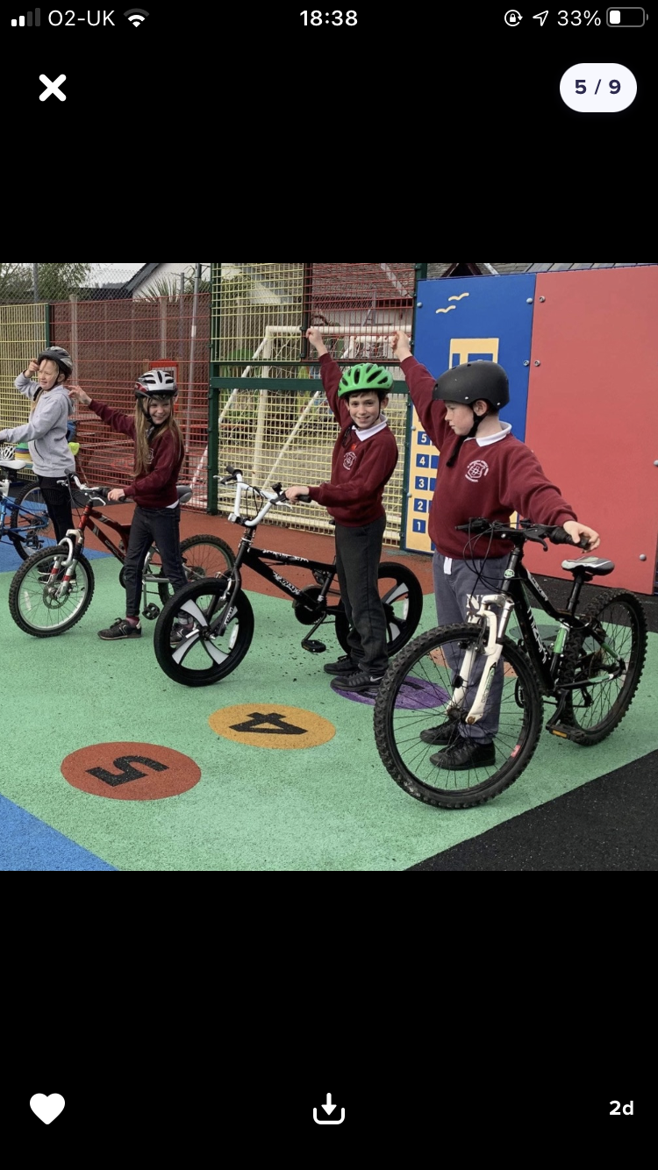

Reception 92%

Year 1 92%

Year 2 96%

Year3 94%

Year 4 96%

Year 5 91%

Year 6 93%

Well done to all our wonderful children for raising money for UKRAINE….!

**DIARY – January 2021**

**Yr. 6 are invited to school at 8.30am for extra maths.**

**Monday 21st March EYFS & KS1 L’al Kendal.**

**BREWARY ARTS KS2 28TH March**

**Friday 17th December – School closed for Christmas.**

**Hope you all have a very merry Christmas!!!!**

**Wrap-around Care** - all payments are due in advance when booking please

Breakfast Club is open from 8.15am until 8.45am £2 per child, per session

After-school Club* runs from 3.15pm until 5.15 pm at £4 per child, per session.

*Please book a week in advance to allow staff planning. If less notice is given we cannot guarantee availability.

**Head Teacher’s Comments**

Dear Parents and Carers,

Last week, we all wore blue and yellow to show our support for Ukraine and our children wrote letters of support to families in Ukraine. We also held a cake sale. We are very proud that as a small school community we raised an amazing **£300.14** to send to the Disaster's Emergency Committee for their Ukraine appeal. Thank you so much for your support.

This week, Year 5 and Year 6 have been taking part in Bikeability, with Bryan from Cyclewise. The children have spent their week learning how to stay safe on the roads, which I am sure you will agree is an essential life skill.

On Monday our EYFS and KS1 children are performing in the L'al sing at Kendal Town Hall. This will be the first time these children have ever performed as a class. Good Luck Explorers!

KS2 are also preparing for a show. They are taking part in the Brewery Dance platform in Kendal next Monday. We have had our dressed rehearsal today. The children look wonderful and their dancing is spectacular. There are a handful of tickets left, if you wanted to watch them.

Year 5's have been enjoying their forest school sessions at Brockhole. Thank you for the LDNPA for funding these sessions for our children.

We have all enjoyed celebrating National Science week in school this week. KS2 have done lots of fun experiments, including weighing balloons, making kites and some sense tests, this afternoon they met Professor Pumpernickel at St. Martin and St. Mary's.

10 of our families benefited from family passes gifted to us from Windermere Science Festival, which is taking place at Windermere Jetty this weekend. Many thanks to them.

First Holy Communion preparation club started yesterday in school, with Mrs Murray. As well as our own children, we welcomed 7 children from other local schools, who will also be receiving the blesses sacrament on May 22nd 2022.

We hope you have a lovely weekend, stay safe!!



**Mrs Bone and Mrs Tansey**

**Head of School & Executive Head**



**ATTENDANCE TEDDY AWARD**

