33333333333 10th June 2022

FRIDAY NEWSLETTER

3rd

Reception 75%

Year 1 33%

Year 2 100%

Year 3 73%

Year 4 100%

Year 5 85%

Year 6 92%

**DIARY - KEY DATES:**

**Thursday 16th June – open morning**

**Friday 17th June – Last swimming lesson**

**Tuesday 21st June – Y6 transition day**

**Thursday 30th June – Heaves Farm visit**

**Hope you all have a lovely weekend!!**

**Wrap-around Care** - all payments are due in advance when booking please

Breakfast Club is open from 8.15am until 8.45am £2 per child, per session

After-school Club* runs from 3.15pm until 5.15 pm at £4 per child, per session.

*Please book a week in advance to allow staff planning. If less notice is given we cannot guarantee availability.

Sports Day 2022

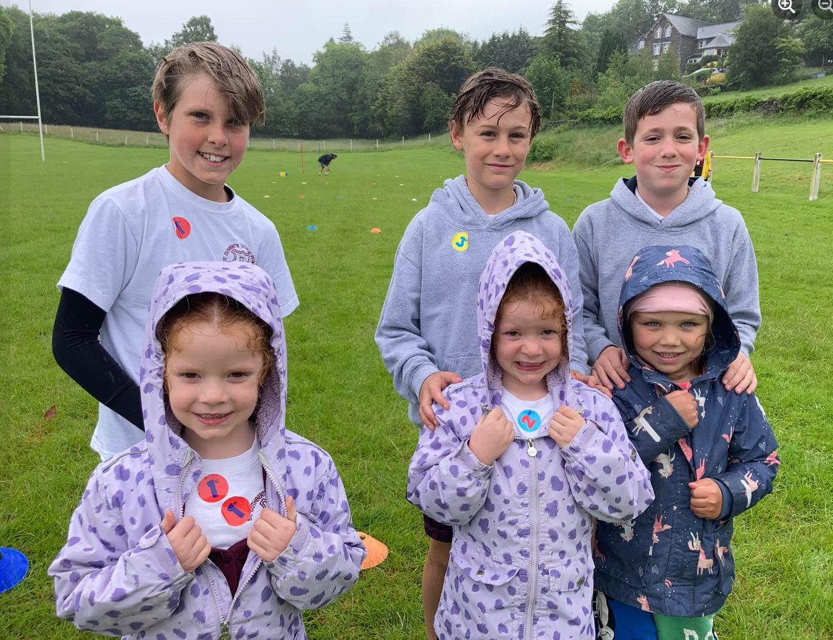

**Head Teacher’s Comments**

Dear Parents and Carers,

We have had another lovely week in school.

The rain did not dampen our fun on Wednesday for our sports day at Windermere RUFC. The children showed great determination and as ever supported one another in true St. Cuthbert's style.  Big thanks to Mr Moorhead for helping us organise the event and thank you to the parents and friends who came down to cheer on the children. If you follow us on Facebook, have a look at the pictures. They will certainly make you smile.

On Monday, we celebrated Pentecost. The children in KS2 wrote some beautiful kennings poems and KS1 made flame crowns. We all rejoiced in the great gift of the Holy Spirit.

Next Thursday 16th June we are holding an open day, between 10-12. Everyone is welcome. Please spread the word and come and see how amazing we are. We have spaces

available in all year groups. For more information, please call the office 01539448125, or just turn up.

We are very excited for our whole school trip to Brantwood on Thursday June 23rd. If you have not yet returned your child's slip and money, please do so by next Wednesday (15th).

Thank you as always for your continued support,

We hope you have a lovely weekend,

Mrs Bone and Mrs Tansey

Stay safe,

Mrs Bone and Mrs Tansey

Mrs Bone and Mrs Tansey

Head of School & Executive Head



WOW! Amazing, year 1 & 4. that’s fantastic!!

Keep

**ATTENDANCE TEDDY AWARD**

